=============================================================================================================================================

**:: LDAP ::\**

1. First we have to open OpenDS(Server).



1. Extract the above folder. Then we have to install(if server is not configured). If server is configured then follow from below steps.
2. Then open(run) "C:\Users\bandaru\Downloads\**OpenDS-2.2.0\OpenDS-2.2.0\bat\control-panel.bat**" file.
3. And enter the password while you configured while installing.

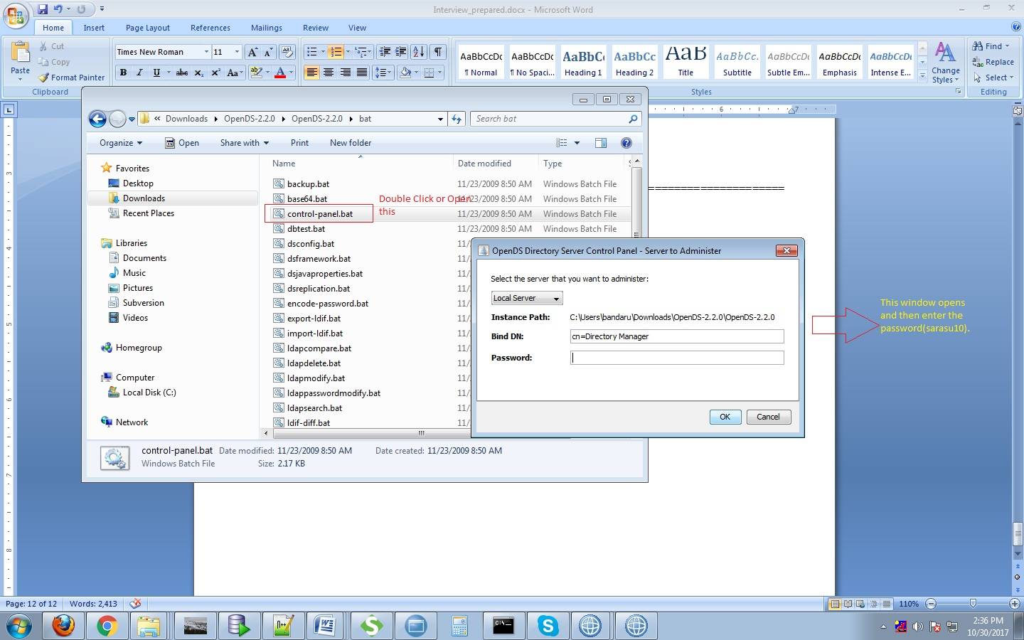

1. Below window OpenDS if password entered is correct. Go to Manage Entries.

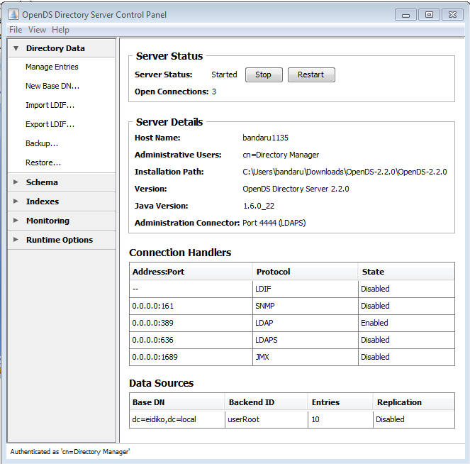

1. Then select BaseDN, right click and select New User and fill up the details.

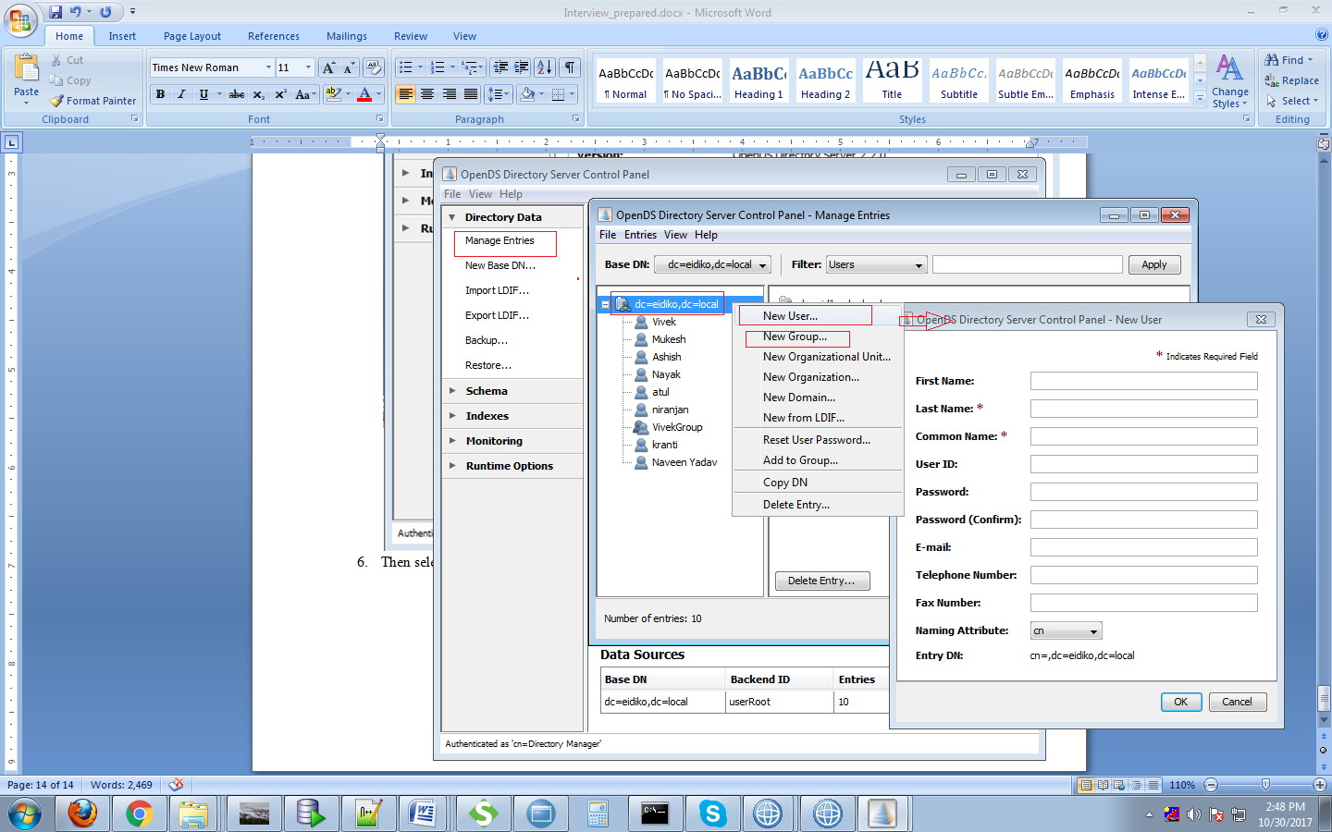

1. Enter FirstName, LastName, CommonName(Imp, Used later in commands), UserId and Password.
2. After this we have to run the following commands.

* mqsicreateconfigurableservice BRKR**(BROKERNAME)** -c SecurityProfiles -o TestLDAP**(ANYNAME)** -n authentication,authenticationConfig,authorization,authorizationConfig,rejectBlankpassword -v "LDAP,\"ldap://localhost**(IPAddress)**:389/dc=eidiko,dc=local?cn\",LDAP,\"ldap://localhost**(IPAddress)**:389/cn=VivekGroup**(GROUPNAME),**dc=eidiko,dc=local\",TRUE

389 is the default port number of LDAP.

* mqsisetdbparms BRKR**(BROKERNAME)** -n ldap::localhost**(IPADDRESS)** -u "cn=mukesh**(COMMONNAME)**,dc=eidiko,dc=local"

mukesh is common name(user name) defined in OpenDS Server.

* mqsistop BRKR**(BROKERNAME)**
* mqsistart BRKR(**BROKERNAME**)

1. Create sample webService Flow. For example

HTTPInput ----------------------- HTTPReply.

1. Create bar file for the application. And give Security Profile which we given in command highlighted in Green Background color. And then deploy the bar file in toolkit.

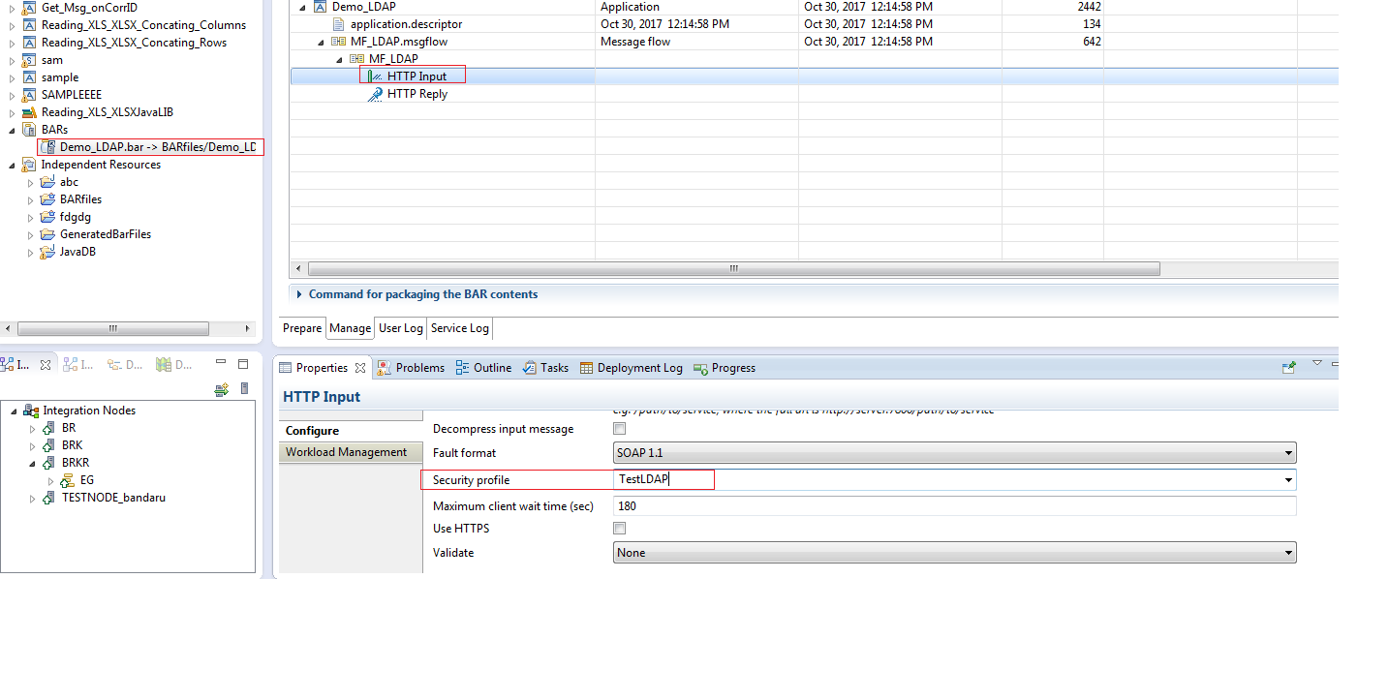

1. Testing: If you give the below url in browser. It asks for the username and password for the user.

http://localhost:7802/testLDAP

or

Configure authentication details(username, password) in soap ui. Click on 1 and then OK and select 2. And give username and password of the user.

